**SkillsUSA 2025 Additive Manufacturing State Challenge**

**Make It Run**

Welcome to the “Make It Run” challenge!

The task at hand is to design and fully print a 4 wheeled vehicle powered only by a single rubber band. The vehicles will then be tested on a “track” for functionality, and additional scoring.

Design Considerations:

* Interlocking parts
* Printed Assemblies
* Snap fits
* Printable Tolerances
* Motion
* Kinetic to Potential Energy

Example of Basic Design

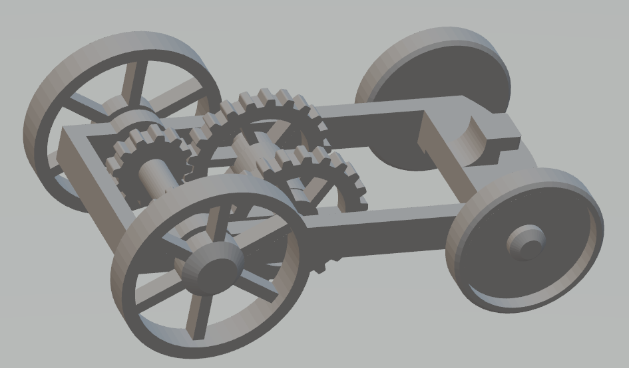

**Competition Requirements**

1. The design **must** be completely 3D printed.
2. The design **must not** contain any outside hardware (axles, screws, washers
3. The design **can** be 3d printed using any technology.
4. The design **must** contain a legibly printed team number/name
5. The design **can** contain 3D printed bodies that are assembled after printing for the final part.
6. The final design **can** use super glue for assembly, for a loss of points (see grading rubric)
7. Parts **must** have printed wheels
8. The design **must** contain at least 3 moving parts
9. Wheels **cannot** be larger than 3 inches in diameter
10. The design **must** be powered only by a single rubber band
11. The printed design **must** have moving bodies.
12. The design **must not** exceed 6” x 4” x 4”
13. 3D Printed Design - Students **must** create a design that:
    * Is original and designed by contestant
    * Print all parts in less than **12** hours total
    * Uses less than **5** cubic inches of model and/or support combined for all parts.

**Tips for Competitors**

Here are some tips to maximize the points awarded to you:

* Build debossed text on a horizontal surface for best results. This may require building the part on its edge or standing up.
* Utilize soluble support structures for print in place assemblies
* Understand the achievable design tolerance of your printer for print in place, or hand assembled designs to allow motion between parts.
* Leverage post-processing techniques to smooth printed bodies.
* Additional moving parts may add to your score but can produce more points of failure on the final assembly.
* Use online resources (YouTube, GrabCAD Tutorials)
* Whenever intellectual property (IP) deters you from a project, try using approximate geometries to communicate the design intent.
* Optional design for additive manufacturing learning resources:
* Stratasys Think Additively™ Masterclass:
  + <https://youtube.com/playlist?list=PLUYaY5EIPtNBdU-s-7l9rl05lBHHlTarI>

**State Competition Procedure**  
On contest day (April 9th) :

1. Students will submit Engineering Notebook (Engineering notebook guidelines below) and show assembled vehicle.
2. Students will have print files available for review in both CAD (.step, .iges, .sldprt, etc.) and mesh (STL, 3MF, OBJ, etc) format.
3. Students will submit final assembly that was created for Regionals
4. Students will present their project to state judges. This will include the assembled vehicle and Engineering Notebook

**State Competition Judging Criteria**

1. The Engineering Notebook should contain robust content, including at a minimum the following:
   1. Be clearly labeled with contestant name(s), date and page # on each page
   2. Begin with a problem statement
   3. Include discovery and documentation of approach to solve problem
   4. Include sketched design concepts with critical features labeled
   5. Critical dimensions clearly labeled in design sketch
   6. Considerations for designing for additive manufacturing distinctly addressed (i.e. part strength, part orientation) especially including any expected risks during printing
   7. Screenshots of the print time and material usage for all printed parts
   8. Design decisions and alternatives are documented and evaluated thoughtfully
2. The design must adhere to the Competition Requirements stated in the prior page.
3. Quality of final assembly
   1. Does it perform the function in the manner it was designed to do?
   2. Does it meet all requirements in contest guidelines?
   3. Do inserted components or multiple printed parts mate together properly?
   4. Did the students design the part with additive manufacturing in mind?
   5. Is there sufficient tolerance between parts for movement?
4. The design must illustrate best practices for “design for additive manufacturing (DFAM)”. Below are some *potential* DFAM metrics to optimize for.
   1. Build Time
   2. Post-Processing/Support Removal Time
   3. Functionality Optimization (gear ratio, pliability, strength, etc.)
   4. Monetary Savings
   5. Material Consumption
   6. Energy Usage
   7. Component Consolidation (lack of store-bought hardware)
   8. Lightweighting for Ergonomics
5. **Presentation Criteria** 
   1. The team clearly describes their understanding of the problem to be solved.
   2. Design Process: good design logic is used for key design choices. Intentional and well-communicated
   3. The presentation is professional and well-rehearsed
   4. The presentation emphasizes quantitative improvements (measured and estimated) of the time, quality, or cost of the improvement as well as any DFAM tactics employed.
   5. Practical evaluation: team demonstrates visually (videos, photos, drawings, animation, etc) the task they improved, both before and after.
6. **Racetrack Setup**
   1. Track will have a stating line and distance markers at 1”, 6”,12”, and with marks every foot after up to 6 feet. Ruler or measuring tape will be used for final measurement above 12”.
   2. Front tire/tires must begin behind the starting line.
   3. A **small** nudge can be used to help get the car moving (see grading rubric)
   4. Each design will have 2 chances to run on the track. The better of the two scores will be used for final judging.
   5. **Final distance of vehicle is measured where the front wheels touch the ground**

**2025 SkillsUSA State Conference**

**Additive Manufacturing Design Challenge**

**Agenda**

**Wednesday April 9, 2025**

12:00 - Orientation

12:15 - Collect Engineering Notebooks and Resumes

12:30 - Teams given the Onsite State Design Challenge

4:00 - Design Challenge Ends

Teams must submit their design to judges via USB drive

**Thursday April 10, 2025**

8:00 - Additive Manufacturing Written Test

8:30 - Team Presentations – Vehicle Design

9:45 - Break

10:00 – Onsite State Design Challenge Testing

Teams will be given their designs (printed parts) for assembly

11:00 - Teams will present the Design Challenge to judges and test designs

12:00 - Competition ends

Teams are responsible for cleaning up the competition area