2025 SKILLS STATE CONTEST: CARPENTRY TOOL LIST

Supplied by the contestant:
(Images are representative, bring any brand or type you prefer.)
- Jigsaw or Handsaw (below) 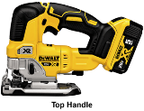
- One 8 pt. crosscut saw (10 pt. or 12 pt. optional)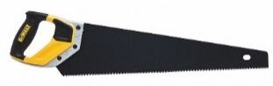
- Claw hammer 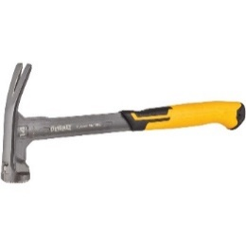
- Framing square 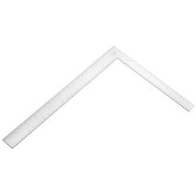
- 16' or longer steel tape measure 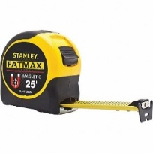
- Utility knife with standard blades 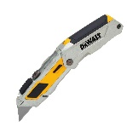
- Two pencils 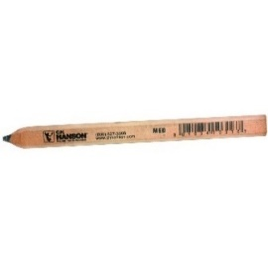
- Wrecking bar or gooseneck pinch bar 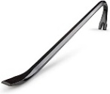
- Cat’s paw (nail puller) 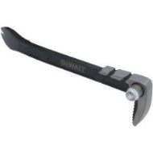
- Chalk box and line 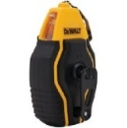

- 24" or 30" spirit level 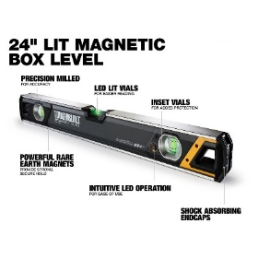

- Carpenter’s tool and nail pouch with belt and/or suspenders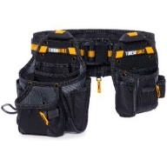
- Stair gauges 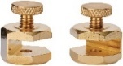
- Combination square and/or speed square 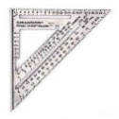

- Construction Calculator 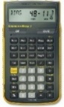
- Power circular saw with new carbide- tipped blade 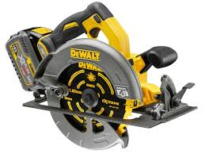

- Corded drill or battery drill with extra battery with a Phillips bit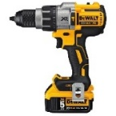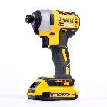

- Twist drill bit set 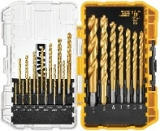

- T-25 & T-20 drill bit 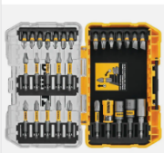

- Quick clamp 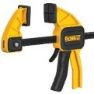

- Flat bar / pry bar 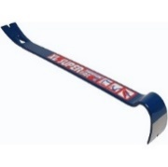

- Torpedo level 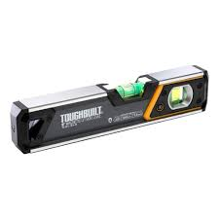

Supplied By Competition
- Hardhat 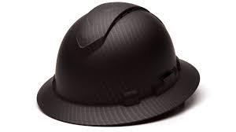

- Safety glasses 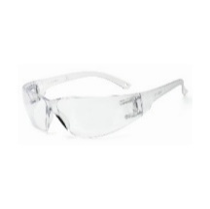

- Earplugs 

- Sawbucks 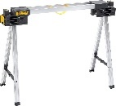

Optional Tools Carpentry State 2025
- Sharpie – for marking steel studs 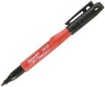

- Drywall saw 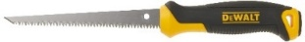
- One set chisel (1⁄4" to 1") 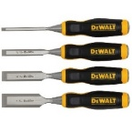

- One each — 1 and 2 pt. Phillips and 4" and 8" standard screwdrivers or one multi-tip with equivalent tip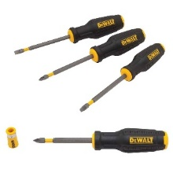

- Coping saw and extra blade 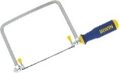
- One nail set 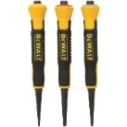
- Straight aviation snip or any metal- cutting snips 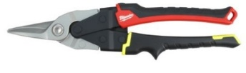

- Locking pliers to work will steel studs 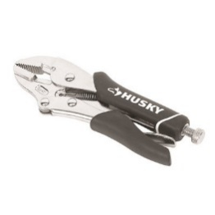

- Combination wood rasp and file (8")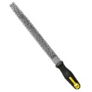

- 25' power cord (UL approved grounded) 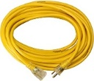

Official Dress For Carpentry Contest

