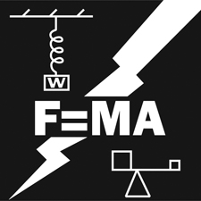Principles of Engineering   
(NC Virtual Specs & Alterations)

\* Refer to the National Contest Technical Standards for full information for this contest.

Supplied By The Contestant

1. Recording Device to record the presentation. Recording must be in MP4 or MOV format only.

2. If electricity is required, contestant must have a 20-foot heavy duty extension cord.

3. Timekeeper to identify 5 minute and 7 minute marks; OR stopwatch or phone for self-identification of time.

NC Contest Notes & Changes

1. Set-up before and Clear after (as identified in the National Tech Standards) should not be recorded and will not be judged for the North Carolina POE Contest this year.

2. The POE presentation will be a 5-7 minute Presentation Recording.

3. Time will start when the contestant begins their presentation by speaking, NOT when the video starts recording. Time will end when the contestant ends their presentation, NOT when the recording stops.

4. The recording should be a CONTINUOUS UNINTERRUPTED RECORDING, with no breaks or splicing of the recording.

5. Recorded Presentation - submit into the Canvas State Contest Access Platform by April 15 midnight.

6. Discussion Paper (see national standards for specifics) – submit into Canvas by April 15 midnight.

7. No unsafe unsupervised actions or skills are required or permitted for this contest.

8. Refer to the National Contest Technical Standards for full information for this contest.